To make performance measurements on a fully regulated linear power supply that uses the 723 IC regulators. Except for its packaging this power supply is an actual low power industrial unit. A simulated test procedure will be followed through the experiment as though this was an actual prototype evaluated by the product development group of a power supply manufacturing company.

1.
Oscilloscope
2.
Half, Full Center Tap, and Full Wave Rectifier Board
And a XFMR board
3.
Ohmmeter (Fluke – 45)
4.
Powerstat-Variable Transformer 3 Amp
5.
1 Capacitors – 250 $μ$fd and a Zener diode
6.
Resistor - Pot
7.
Various lengths of hook-up wire and instrument leads as required

R-max= 0.8397k I= 150mA Using a R- Load $≅$ 38 ohm
Output Voltage= 5.048v R-Load = $\frac{5.048v}{150mA}$ = 33.653 ohms V-Load= 4.92v

 | Vcf | Vcfp-p ripple | Vout-dc | Voutp-p ripple
LL-NL | 17.487V | 520mV | 5.044V | 130mV
HL-NL | 20.980V | 500mV | 5.043V | .0500V
LL-FL | 12.420V | 10.23V | 4.920V | 1.310V
HL-FL | 15.799V | 10.80V | 5.042V | 160mV

- Ripple rejection from input to Output in db:
For HL-NL 20$log({\frac{120\sqrt{2}}{5.94m} })$= 88db

For LL-NL 20$log({\frac{105\sqrt{2}}{5.61m} })$= 90db

Load and Line Regulation for the Capacitor and Output Voltage
Parameters |  | Parameters
 | % Full Load Regulation |  | % No Load Regulation
V-OUT | $$\left(\frac{5.042V- 4.920V }{5.042V}\right)*100=2.42$$ | V-OUT | $$\left(\frac{5.044V- 5.043V}{5.044V}\right)*100=0.02$$
VCF | $$\left(\frac{15.799V- 12.420V }{15.799V}\right)*100=21.39$$ | VCF | $$\left(\frac{20.98V-17.487V}{20.98V}\right)*100=16.65$$
 | % Low Line Regulation |  | % High Line Regulation
V-OUT | $$\left(\frac{5.044V-4.920V}{5.044V}\right)*100=2.46$$ | V-OUT | $$\left(\frac{12.01V-13.574V }{12.01V}\right)*100=0.02$$
VCF | $$\left(\frac{17.487V-12.420V }{17.487V}\right)*100=28.9$$ | VCF | $$\left(\frac{12.01V-29.952V}{12.01V}\right)*100= 24.7$$

- Vout-min,Vout-max, over the full range of R6 at no load.

R6-min = 2.61 ohms Vout-min = 03.597v
R6-max= 3.2k ohms Vout-max= 10.155v

- Programming resistance in ohms/volts using$\frac{∆R6}{∆Vout}$.
Rs= $\frac{∆R6}{∆Vout}$ = $\frac{(3.2k-2.61)}{(10.155-03.597)}$ = 487.556 ohms

- Estimate Vinac drop-out by setting the output to 5v at 100mA and then reducing the input VARIAC voltage until the output starts to become unregulated. Record V-ac read on the VARIAC at this point.
V-ac read = 3.5volts
VARIAC = 55 volts

- Set Vinac to 105VAC, V-out=5v and estimate the short circuit current by shoring the output and measuring the voltage across R5, Isc =$\frac{Vrs}{R5}$.

VR5= 0.8241volts I-sc= $\frac{VR5}{R5}$ = $\frac{0.824 v}{5 ohms}$ = 164.82mA
R5= 5 ohms

- Determine additional points on the current limit curve:
(V-out=5v, Vinac=105VAC)

Current Response
R-Load | V-out | I-Load
50 | 5.157v | 103.14mA
40 | 5.063v | 126.58mA
30 | 4.711v | 157.03mA
20 | 1.078 | 122.90mA
10 | 2.458 | 107.80mA
- Using the measurements of parts (d) and (e) above, sketch the approximate current limit curve of the power supply V-out vs I-Load.
.
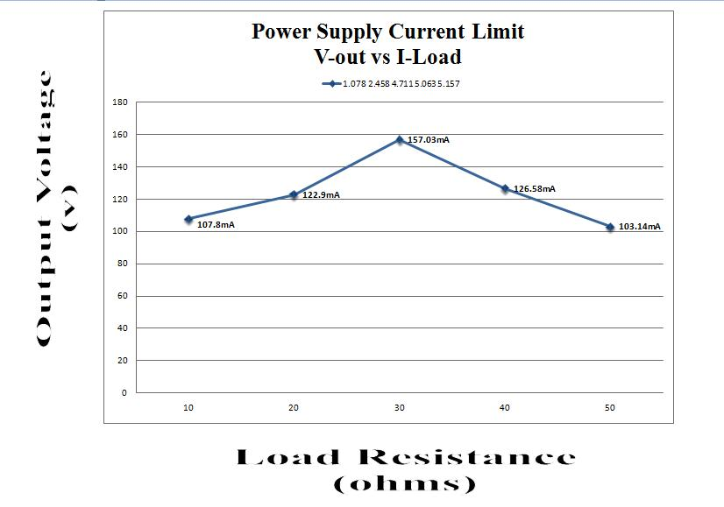

- From the specification data sheet provided in your text obtain for the 723 regulator, the typical values of:

- The ripple rejection.
- The reference voltage.
- The current limit offset voltage Vos.

- Using these typical values and referring to the power supply diagram of fig.1, determine typical values for the following: (Use Cf = 250ufd)

- The expected output voltage range (Vomax-Vomin) for the full range of R6.

V-out= 5v R6= 5k Rp=3k R6||R3=1.875K R3=500 VR3=?

I= $\frac{5V}{1.875K}$ = 2.667mA VR3 = (500) (2.667mA) = 1.33v

Vo-min= 1.33 (.5) + 3k (1m) = 3.667v
Vo-max= 1m (5k + 500 + 5k + 13.5) = 13.5v

- The programming current and the programming resistance in ohms/volt.
Ip= $\frac{5V}{1.875K}$ = 2.667mA VB= 1.33v → Rs= $\frac{1.33V}{2.667mA}$ = 498.69ohms

- The p-p ripple across Cf assuming 100mA full load current and blocking time of 6ms.
Toff= 60ms Cf=250ufd Vpp= $\frac{\left(Toff\right)(Iload)}{Cf}$= $\frac{\left(6ms\right)(100mA)}{250ufd}$ = 2.4v
Vpp= 2.4V

- The expected output p-p ripple at full load using the typical ripple ratio spec from input to reference and assuming a nominal output of 5vdc.
Vo-ripple-pp= 2.4V ($\frac{1}{100}$) (13.5) = 324mv

- The approximate value at which R3 must be set for current limiting at 150mA when Vo =5v.
R3= $\frac{5}{150m}$ = 33.33 ohms

- The approximate value of the short circuit current using the value of R3 obtained in step5.
Isc= $\frac{5V}{33.33}$ = 151.515mA

Compare your theoretical expectations to the experimental measurements whenever possible and comment on the overall performance of this fully regulated power supply.

Comparison Table
Parameters | Theoretical | Experimental | %error | Comments
R-programming | 498.69ohms | 487.556 ohms | 2.14 | Average Resistance needed to maintain the current in the circuit balanced
Vout-max | 13.5v | 10.155v | 24.4 | Maximum Output Voltage for the no-load case
Vout-min | 3.667v | 3.597v | 1.91 | Minimum Output Voltage for the no-load case
Isc | 151.515mA | 164.82mA | 8.78 | Maximum current allowed across the resistor 5 while short circuiting output
R3-limit current | 33.33 ohms | 33.653 ohms | 1.08 | Maximum resistance allowed by the short circuit maximum current

From parameters obtained in the comparison table along with the power supply current limit graph, I have come to the following conclusions:

First, the greater is the voltage across the resistor the greater is the current through the circuit as long as the resistor does not exceed the maximum value. This way, the circuit will protect the power supply in case an accidental overload situation arises.
Second, the maximum resistor will depend on the desired current and voltage at which the circuit will be set up after short circuiting the output. The reason why is so the circuit protects the power supply from short circuit at the output.

Finally, the linear power supply with 723 IC regulators maintains a desire current in the circuit before and after the load has been applied to the circuit. This current, also current limit, is to protect a power supply from a potential.

